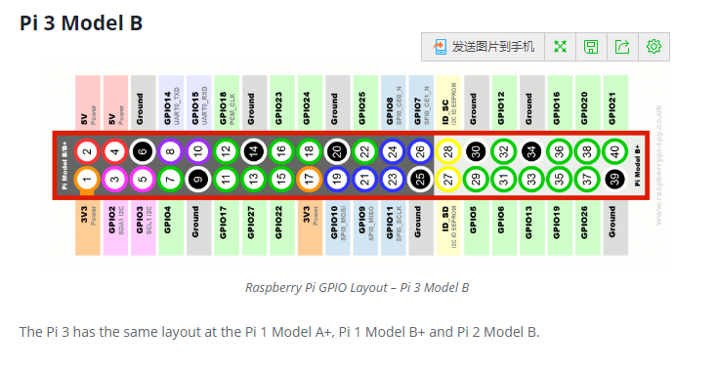

Install RPi.GPIO Python Library
12
BY MATT ON MAY 30, 2012PYTHON, TUTORIALS & HELP
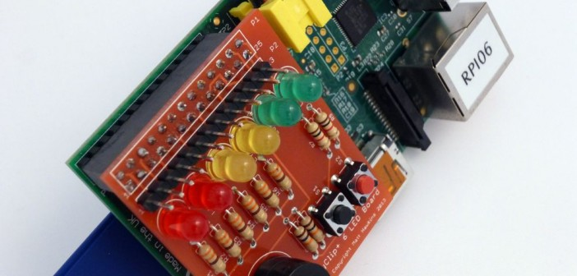
The RPi.GPIO Python library allows you to easily configure and read-write the input/output pins on the Pi’s GPIO header within a Python script. Thankfully this library is now including in the standard Raspbian image available from the Foundations Download Page.
If you are using a fresh image you don’t need to install it but I’ve kept the instructions here in case you ever want to try a manually installation.

Method 1 – Install from repository
If the package exists in the Raspbian repository is can be installed using apt-get. First you need to update the available package versions :
sudo apt-get update
Then attempt to install the RPi.GPIO package :
sudo apt-get install rpi.gpio
If it isn’t already installed it will be installed. If it is already installed it will be upgraded if a newer version is available.

Method 2 – Manual Installation
The package is available from http://pypi.python.org/pypi/RPi.GPIO and the current version is 0.5.11 (February 2015). If this version is updated you will need to make appropriate changes to the version number in the commands below.

Step 1 – Download the library
wget https://pypi.python.org/packages/source/R/RPi.GPIO/RPi.GPIO-0.5.11.tar.gz

Step 2 – Extract the archive to a new folder
tar -xvf RPi.GPIO-0.5.11.tar.gz

Step 3 – Browse to the new directory
cd RPi.GPIO-0.5.11

Step 4 – Install the library
sudo python setup.py install

Step 5 – Remove the directory and archive file
cd ~
sudo rm -rf RPi.GPIO-0.*
This will now mean you can use the library within Python.
Example Usage
import RPi.GPIO as GPIO

# to use Raspberry Pi board pin numbers
GPIO.setmode(GPIO.BOARD)

# set up the GPIO channels - one input and one output
GPIO.setup(11, GPIO.IN)
GPIO.setup(12, GPIO.OUT)

# input from pin 11
input_value = GPIO.input(11)

# output to pin 12
GPIO.output(12, GPIO.HIGH)

# the same script as above but using BCM GPIO 00..nn numbers
GPIO.setmode(GPIO.BCM)
GPIO.setup(17, GPIO.IN)
GPIO.setup(18, GPIO.OUT)
input_value = GPIO.input(17)
GPIO.output(18, GPIO.HIGH)
Use the latest version of Raspbian. This library is now installed by default so you do not need to install it manually.

树莓派多版本python设置默认python3
2018年01月18日 18:22:09
阅读数：1834
如果有的系统没有自带的3.4版本，需要安装一下
sudo apt-get install python3
- 1
然后把python的链接删掉
sudo rm /usr/bin/python
- 1
新建一个链接
sudo ln -s /usr/bin/python3.4 /usr/bin/python
- 1
查看一下版本
python
- 1
显示为：
Python 3.5.2 (default, Nov 17 2016, 17:05:23)
[GCC 5.4.0 20160609] on linux
Type "help", "copyright", "credits" or "license" for more information.
个人分类： 树莓

